**Ceramics 1 Syllabus**  Ms. Heida 763-506-8546

[angela.heida@ahschools.us](mailto:angela.heida@ahschools.us)

**Common Art Department Syllabus:**

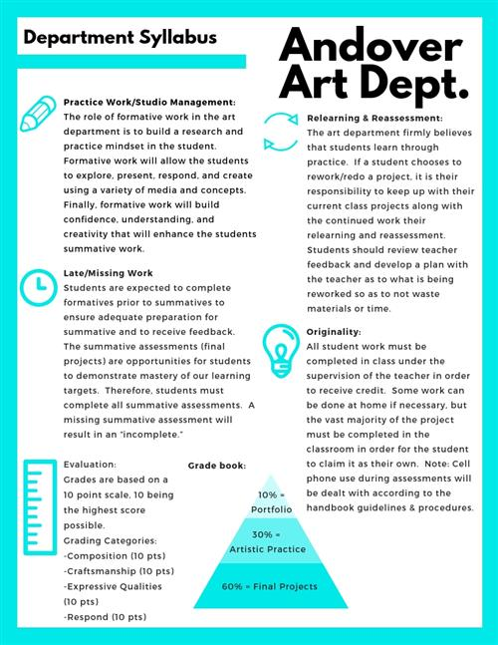

**Projects:**

**Textured Sphere:**  You will learn the traditional method of forming a pinch pot in clay. Then you will individualize it with textures and a unique opening.

**Slab Mug**: You will learn how to create clay slabs and form them into a simple mug with a handle. Artist Dick Cooter will be introduced.

**Angled Slab Vessel*:** You will learn basic hand-building techniques used in slab construction to create an angled slab vessel. Line design and the concept of glaze resist will be introduced.

**Berry Bowl:** You will make learn to roll coils and attach them to make a decorative strainer!

**Covered Coil Vessel*:** You will learn basic hand-building techniques used for coil construction to create a 12” clay vessel. You will learn how to make a variety of functional lids and design one for your vessel. The surface of your vessel will show an overall texture or design that includes adding and subtracting clay. Artist Maria Martinez will be introduced.

**Wheel Thrown Work*:** You will learn the basic techniques of throwing a vessel on the potter’s wheel. Your goal is to throw a work that is 4” high, with wall thickness of ¼”, centered, and well-trimmed. Artist Warren MacKenzie will be introduced.

**Series Final Project*:** You will demonstrate your mastery of basic ceramic skills by producing a series of related work. These will be based on the Art Element and Design Principle of your choice. They must be at least 6” in some direction, and have impressive surface design and details. They may be constructed in the method of your choice. Art focus: Modern Ceramic artists and sculptors.

**Grading:** The summative projects (“*” above) receive three grades on a 10 point scale for Craftsmanship, Expressive Qualities and Form within the Final Project category. Formative projects receive one grade under Artistic Practice showing progress toward the learning target. Artistic Practice also includes is based on a student’s contribution to the art studio and use of work time. You will receive full points if you are on task in class, on time for class, follow school policies on food and phones. If you are ever unsatisfied with a grade please see me and we can discuss how to improve it within grading deadlines. Late work will be accepted if received before the next projects deadline. I do not give extra credit however; you have the option to redo any project for a higher grade within grading deadlines. **All projects must be completed to receive credit for this class.**

School and district policies on cell phone appearance during tests/quizzes result in a zero; and that modifications regarding grading and IEP and 504 plans will be followed.

If your parent(s) and/or guardians have a special art related talent or work that they would be willing to share with the class, please let me know. It would be an enriching experience for the class.